**Medisys – XML File Processing through REST services**

**Initial Setup to use the tool:**

1. **Need to add certificate in the machine**



1. Unzip the Certificates.zip and follow the below process
2. Go to the certificate path and Import the certificate (Double click on the certificate and Click on Import button)
3. Open cmd in ElevatedAccess
4. keytool -import -alias automate -keystore "java path\jre\lib\security\cacerts" -file "certificate path" - password: changeit

(keytool -import -alias automate -keystore "C:\Program Files\Java\jdk1.8.0_161\jre\lib\security\cacerts" -file "C:\Users\AF72532\Documents\APICERTS\GBD.cer" - password: changeit)

1. keytool -import -alias automate -keystore "java path\jre\lib\security\cacerts" -file "certificate path" - password: changeit

(keytool -import -alias automate1 -keystore "C:\Program Files\Java\jdk1.8.0_161\jre\lib\security\cacerts" -file "C:\Users\AF72532\Documents\APICERTS\SCUAT.cer" - password: changeit)

1. Close command Prompt
2. Restart the machine if not working
3. **Need to update Environment Variable with Java path**
   1. Right Click on ‘My Computer’ 🡪 Properties 🡪 Advance System Settings 🡪 Environment Variables 🡪 Edit in ‘Path’ under System Variables 🡪 add javapath “C:\Program Files\Java\jdk1.8.0_161\bin” at the end and save.

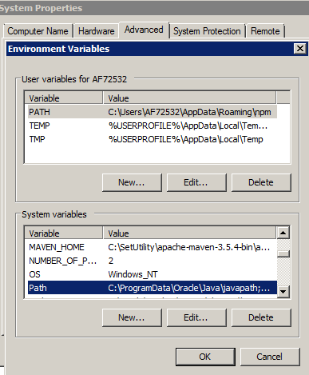

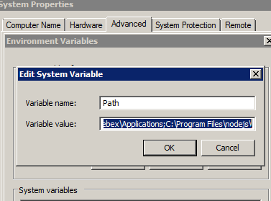

* 1. On completion, validate the java version

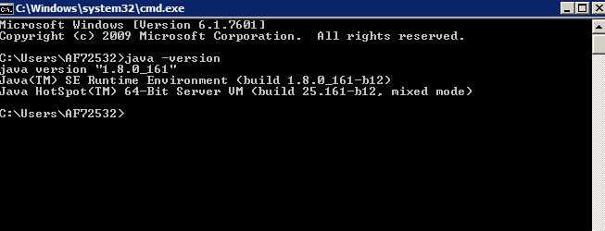

**Environment Details:**

|  |  |
| --- | --- |
| Environment | URLS |
| GBD  7Q | [https://uats-gbd-soa-services.anthem.com:443/MedisysWS-v1/transaction]( https://uats-gbd-soa-services.anthem.com:443/MedisysWS-v1/transaction) |
| GBD  5Q | [https://uats-gbd-soa-services.anthem.com:444/MedisysWS-v1/ transaction](https://uats-gbd-soa-services.anthem.com:444/MedisysWS-v1/nextresponse) |
| GBD  4Q | [https://uats-gbd-soa-services.anthem.com:445/MedisysWS-v1/ transaction](https://uats-gbd-soa-services.anthem.com:445/MedisysWS-v1/nextresponse) |
| GBD  6D | [https://devs-gbd-soa-services.anthem.com:443/MedisysWS-v1/ transaction](https://devs-gbd-soa-services.anthem.com:443/MedisysWS-v1/nextresponse) |
| GBD  5D | [https://devs-gbd-soa-services.anthem.com:444/MedisysWS-v1/ transaction](https://devs-gbd-soa-services.anthem.com:444/MedisysWS-v1/nextresponse) |

**Steps to follow:**

1. Open jar file “XML File Processing Tool”



1. Below UI will be displayed

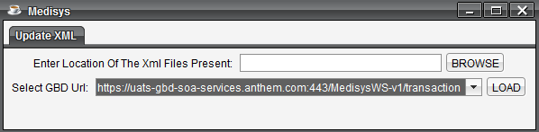

1. Click on Browse Button and enter the location of xml files present in the first Textbox (“Enter Location of the xml files present”)

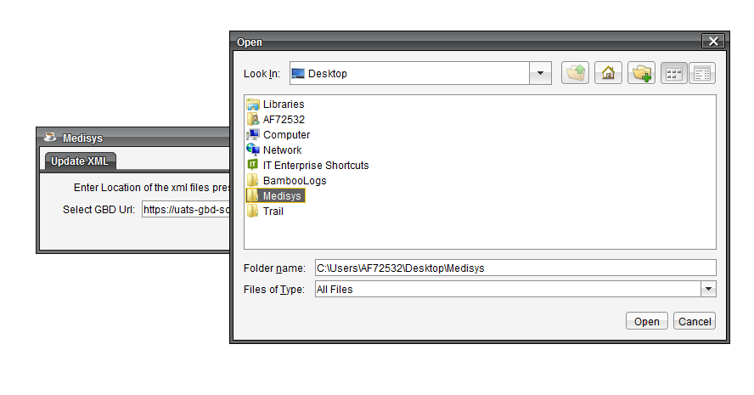

1. Click on Open, selected location will be displayed in the textbox

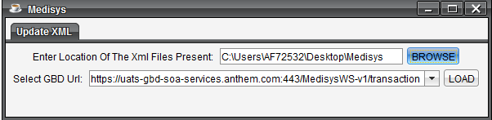

1. Select any GBD URL from the dropdown displayed, where the xml should be processed.

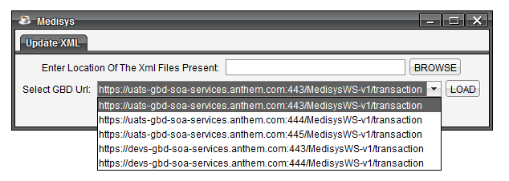

1. Then click on Load button

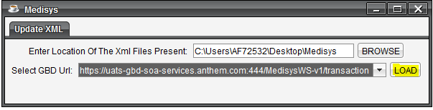

1. The xml files present in the folder will be processed with the GBD URL selected and on completion, generates a log report in the same location where the Xml files are present which contains the status of Xml files as ‘Processed’ or ‘Not Processed’.

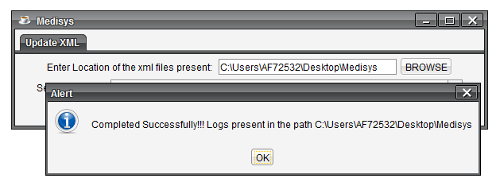

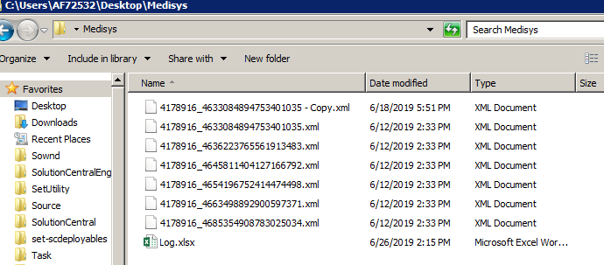

1. Logs displayed as below (Filename and Status).

